
Thursday, August 23, 2007
Kaanapali Land Management pursuing Pu’ukoli’i Mauka
BY MARK VIETH/EDITOR
KAANAPALI – Kaanapali Land Management Corp. (KLM) last week unveiled plans for Pu’ukoli’i Mauka, a 940-unit development proposed at the former Pu’ukoli’i Village plantation camp.
Plans call for a mix of land uses: 940 housing units, with 50 percent affordable; community facilities; recreational features; and open space. (View the plans at www.kaanapaliland.com.)
Pu’ukoli’i Mauka was a component of KLM’s Kaanapali 2020 land use plan spanning from the Lahaina Civic Center area to Honokowai.
KLM recently separated Pu’ukoli’i Mauka from 2020 because it was approved in the 1990s, and there is a strong need now for affordable housing on the West Side, said Howard Hanzawa, Kaanapali Land Management’s vice president.
Pu’ukoli’i Mauka was approved, with conditions, by the state Housing Finance and Development Corp. under Act 15 as an affordable housing project in 1993.
To move forward, KLM will seek approval from the
Hawaii Housing Finance and Development Corp. and state Land Use Commission to change two key conditions: reduce the number of affordable units from 60 percent to 51, and eliminate the requirement that construction cannot commence until the Lahaina Bypass is built, Hanzawa explained.
He added that 14 years have passed, and there are no concrete plans for the Lahaina Bypass through Kaanapali.
KLM – formerly Amfac/JMB Hawaii Inc., then Kaanapali Development Corp. – has already contributed millions of dollars toward the design, environmental impact statement and entitlements for the bypass, a roadway planned from Launiupoko to Honokowai to increase the West Side’s traffic network and ease congestion on Honoapiilani Highway.
Since the early 1990s, Hanzawa said the West Side has grown, the business base has expanded and more workers have been hired.
There are an estimated 35,000 employees in West Maui today, and a recent survey by Lahaina Bypass Now found that 41 percent of area workers commute.
He believes there is a correlation between the lack of affordable housing in West Maui and congested traffic in the region.
Plotted through a community-based planning process, Pu’ukoli’i Mauka meets the 51 percent affordable housing requirement for new major projects set in the county’s Residential Workforce Housing Policy, so the county and state support the project, Hanzawa said.
Kaanapali Land Management is complying with County of Maui standards for roadways and parks within the project, so the firm can dedicate them to the county and help keep maintenance fees for homeowners down, he noted.
KLM is talking to employers about the possibility of picking up workers at Pu’ukoli’i Mauka in small buses, and exploring if it can give preference for home reservations to West Maui workers first, he said.
“I’m surprised other projects have not looked at this,” Hanzawa added.
A hearing before the HHFDC is tentatively slated for October, with the LUC meeting expected shortly after.
An “optimistic” timetable for Pu’ukoli’i Mauka would see KLM conduct design and obtain permits in 2008, begin building the infrastructure in 2009, and start work on the first units in 2010 with a six- to ten-year build out.
Hanzawa explained that 16,000 units were approved under the Act 15 fast track process for affordable housing, yet less than 600 were built.
“Developers really couldn’t do it at 60 percent,” he said.
In addition to Pu’ukoli’i Mauka, KLM is pursuing a second affordable housing project, Wainee, in Lahaina.
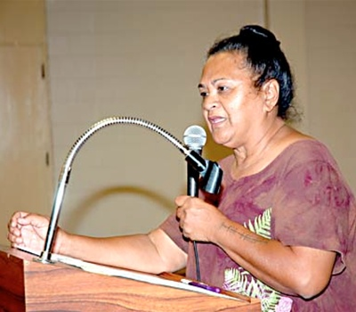
Patty Nishiyama spoke at a community meeting for Pu’ukoli’i Mauka last week Wednesday at Lahaina Civic Center. Residents have consulted with the developer on the plans.

